Game Theory
What Is Game Theory?
Game theory examines how individuals and entities, referred to as players, strategize and make decisions in competitive environments. As a theoretical framework, it models scenarios involving conflicts of interest and provides insights into possible outcomes and strategies. Often described as the science of strategy, game theory helps predict and explain the decisions made by independent and competing actors in strategic settings. Its applications are vast, spanning fields including business, psychology, economics, and politics to address complex scenarios such as pricing strategies, mergers, and negotiations.
Key Takeaways
Game theory is a method of studying strategic decision-making among rational players, applicable to various fields like economics, business, and psychology.
The Nash equilibrium is a key concept in game theory, where no player can benefit by changing strategies unless others do so as well.
Game theory categorizes strategic interactions into several types of games, including zero-sum and non-zero-sum, cooperative and non-cooperative, and one-shot versus repeated games.
Real-world applications of game theory include pricing strategies in business, resolving project management dilemmas, and understanding consumer behavior.
Despite its broad usage, game theory's effectiveness can be limited by its reliance on the assumption of rational behavior, which often overlooks the complexities of human emotions and social factors.
Understanding the Mechanics of Game Theory
The goal of game theory is to explain the strategic actions of two or more players in a given situation with set rules and outcomes. Any time a situation with two or more players involves known payouts or quantifiable consequences, we can use game theory to help determine the most likely outcomes.
The focus of game theory is the game, which is an interactive situation that involves rational players. The key to game theory is that one player's payoff is contingent on the strategy implemented by the other player.
The game identifies the players' identities, preferences, available strategies, and how these strategies affect the outcome. Depending on the model, various other requirements or assumptions may be necessary.
Game theory has a wide range of applications, including psychology, evolutionary biology, war, politics, economics, and business. Despite its many advances, game theory is still a young and developing science.
Important
According to game theory, the actions and choices of all the participants affect the outcome of each. It's assumed players within the game are rational and will strive to maximize their payoffs in the game.1
Key Terms in Game Theory Explained
Here are a few terms commonly used in the study of game theory:
Game: Any set of circumstances that has a result dependent on the actions of two or more decision-makers (players).
Players: A strategic decision-maker within the context of the game.
Strategy: A complete plan of action a player will take given the set of circumstances that might arise within the game.
Payoff: The payout a player receives from arriving at a particular outcome. The payout can be in any quantifiable form, from dollars to utility.
Information set: The information available at a given point in the game. The term "information set" is most usually applied when the game has a sequential component.
Equilibrium: The point in a game where both players have made their decisions and an outcome is reached.

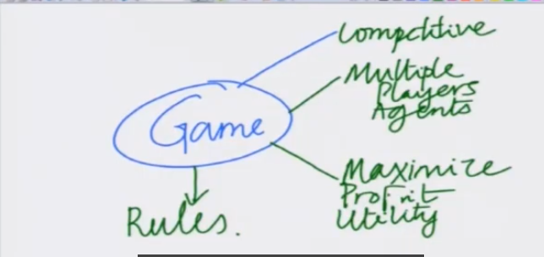
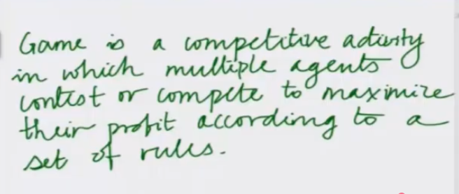
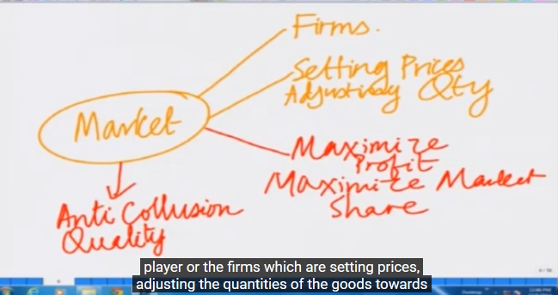
RULES
AIM
HOW THEY COMPETE
HAS

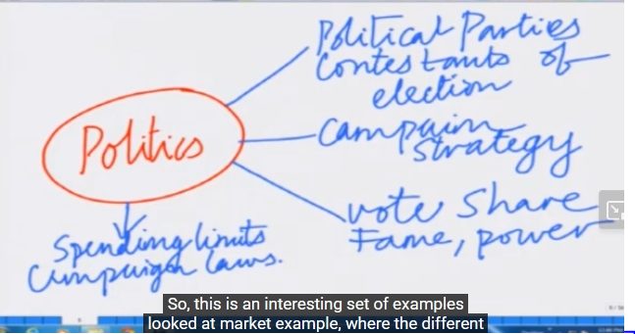
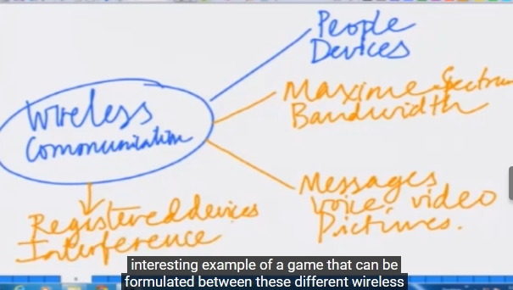
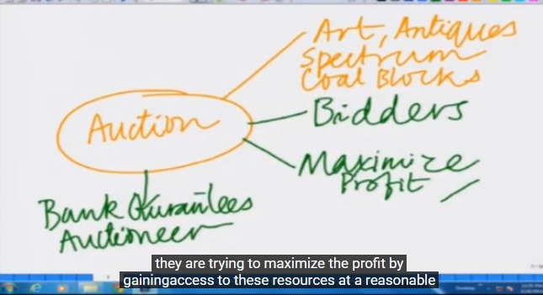

An example: Rock-Paper-Scissors.
The game Rock-Paper-Scissors (RPS) is represented in Figure 1 in what is called a
game box. There are two players, 1 and 2. Each player has three strategies in the
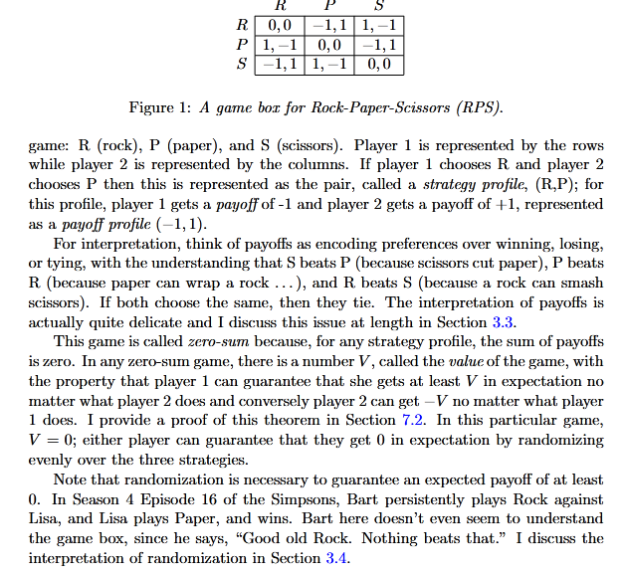
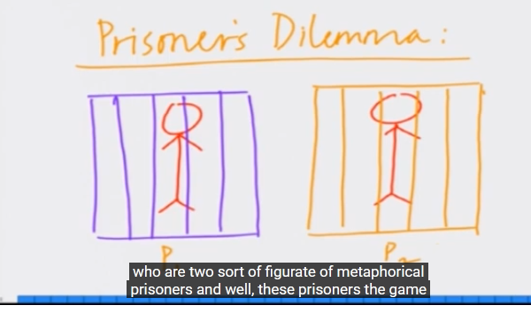
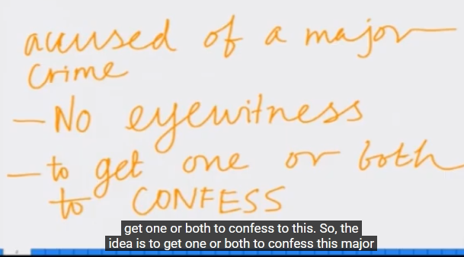
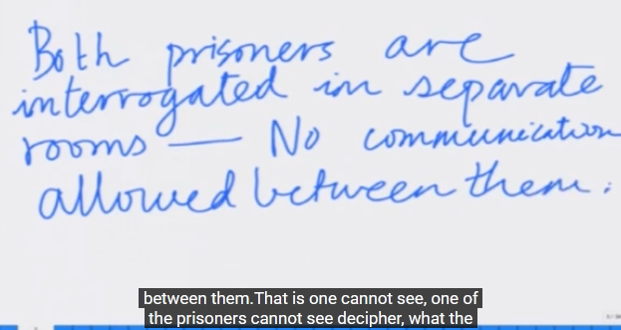
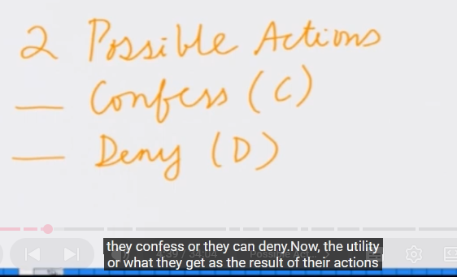
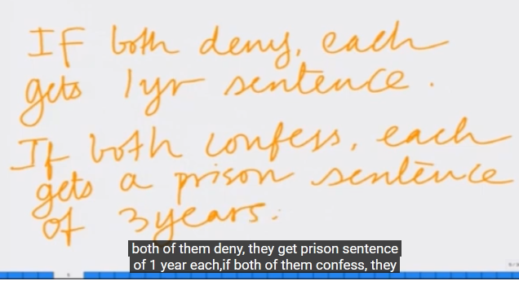
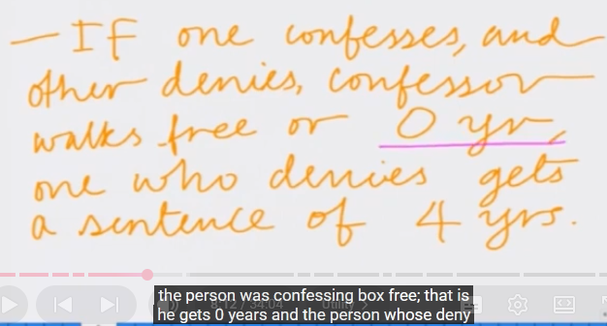

MODEL DIAGRAM FOR THIS GAME
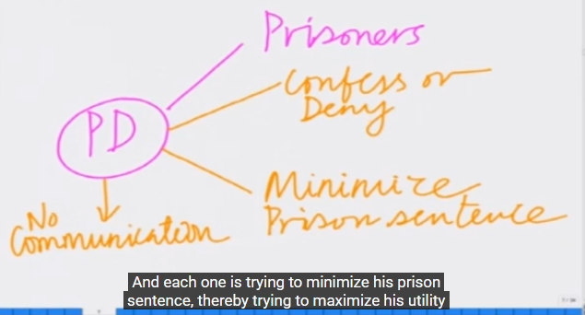
PRISINOR DELIMA
RULE
AIM
STRATEGY
PLAYER

NOW LETS DRAW THE GAME TABLE ; WHERE
P1 SHOWS ACTION FOR PALYER P1(ALSO CALLED ROW PLAYER) AND P2 SHOWS ACTION FOR PLAYER P2.
SUPPOSING
CC - AS (-3,-3 ) ASSUMING BOTH CONFESS SO THE PUNISHMENT IS OF 3 YEAR EITHER AND -VE REPRESENT Minimize PINISHMENT.
DD - AS (-1,-1 ) ASSUMING BOTH DENIES SO THE PUNISHMENT IS OF 1 YEAR EITHER.
CD - AS (0,-4 ) ASSUMING P1 CONFESS AND P2 DENIES ,SO CONFESSOR WILL GET FREE AND DENIOR GETS SENTENCE OF 4 YEAR.
DC - AS (-4,0 ) ASSUMING P1 DENIES AND P2 CONFESS ,SO CONFESSOR WILL GET FREE AND DENIOR GETS SENTENCE OF 4 YEAR.
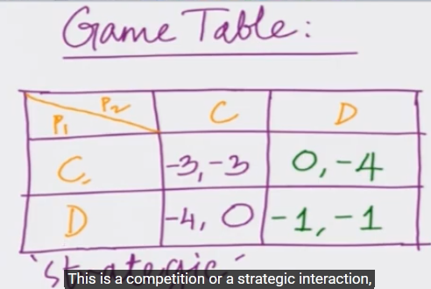
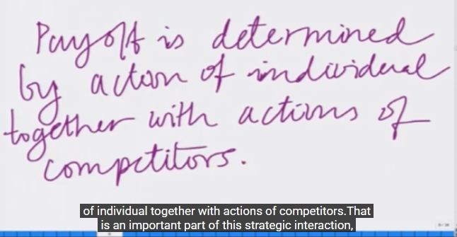
MATHEMATICAL REPRESENTATION
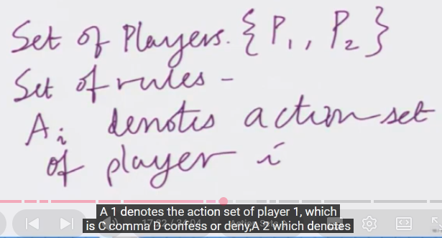

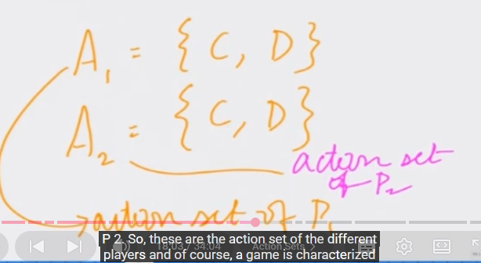
CALCULATE OUTCOME
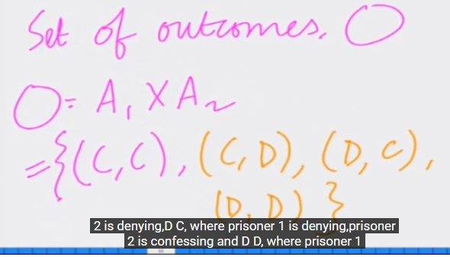
TO CALCULATE UTILITY OF i-th PLAYER:
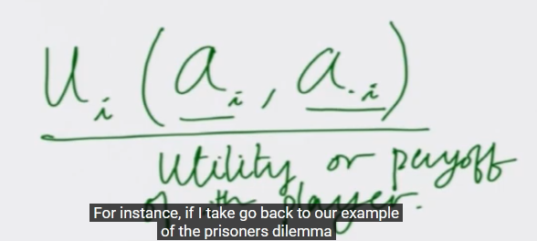
To calculate utility of player 1
